What is a heroic action?

- Study the pictures below. Which picture displays a heroic action? Discuss it in a group.
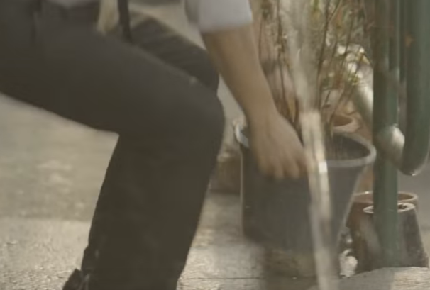


Picture 1 Picture 2



Picture 3 Picture 4



Picture 5

2. Watch the video about a person who did many heroic actions. Answer the following questions in a separate sheet of paper.

- Mention three heroic actions that the man did as he passed his days.

- Choose one heroic action that moves your heart the most and explain your feelings.

Modified from https://www.youtube.com/watch?v=xjLYwZkQ-rw

